Campground workflow.
- Set up a reservation for a member, as an admin.
- Block-outs
- Edit a Reservation
- Edit Email Templates
- Refunds (to do)
- Message Member directly in system
- What if… someone booking the same site at the same time, what will that look like if it happens to me?
- Reports. Quick summary of what’s going on in any given week.
- Check Ins.
- Browser Cache Reset

Campground workflow
- Set up a reservation for a member, as an admin
  - Logged into: roundbottom.fmca.com/index.php
  - Find the Member number (membership directory or elan)
  - Search Member-menu
  - 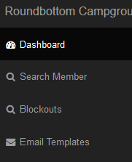
  - Type member number:
  - Example: F478686g9
  - Press “Search”
  - “Create Campground Stay”
  - 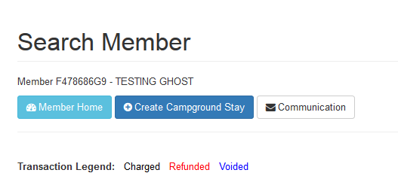
  - Enter arrival date, and departure date, and Search Available Campsites
  - 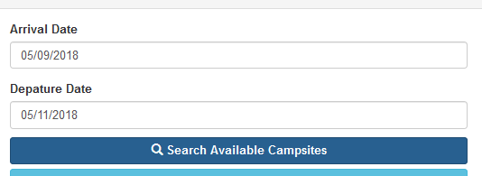
  - Select from available campsites and “Book Now”
  - Fill in the booking form.
  - 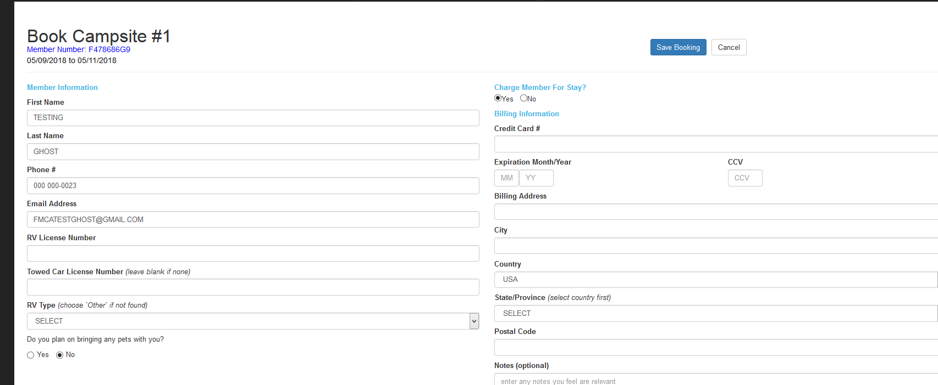
  - “Save Booking”
  - Will say: The booking is completed for the member, click here to return to the member information page.
  - Click the word ‘here’ to see that it booked.
  - Looks like 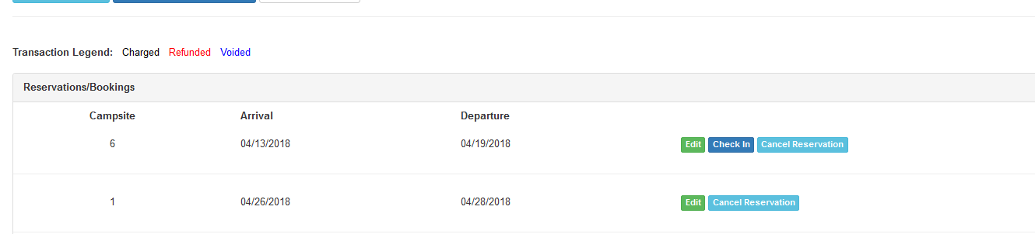

- Block-outs:
  - Select blockouts
  - 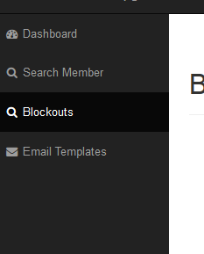
  - Fill in start date, end date, number of sites to block out (number between 1 and 24)
  - 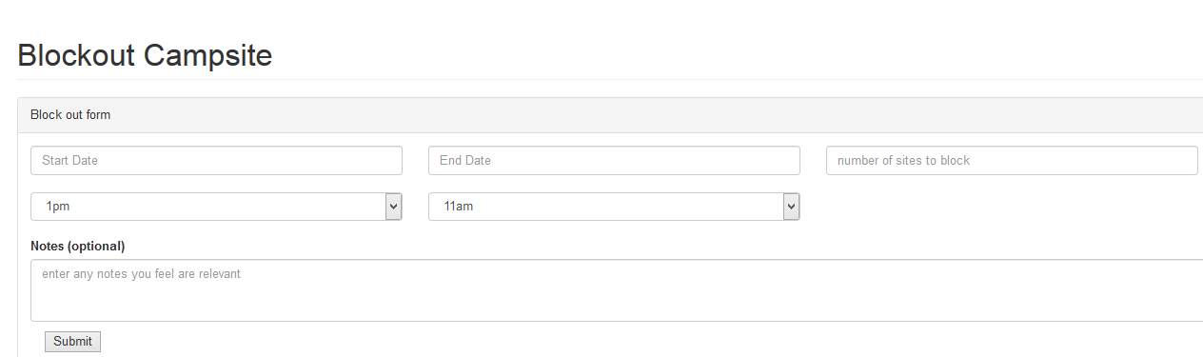
  - See blockouts in blockout report
  - Note: based on prior discussions we’ve had, I’ve changed the order of priority of blockouts, instead of blocking order of 1,2,3,4,5,6,7,8,9,10,11,12,13,14,15,16-24, we are blocking in priority of preference: 12,11,10,9,8,7,6,5,4,3,2,1,13,14,15,16-24
- Edit Customer Reservation: (change dates, or change site)
  - Click on the “Edit” button.
  - 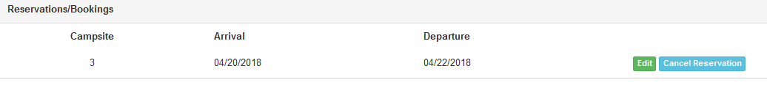
  - Click on the “Change” button:
  - 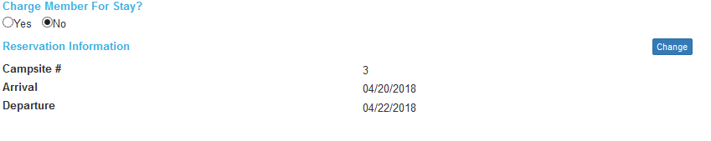
  - Click “Change Campsite” in order to change the campsite, or Change dates in order to change the dates.
  - 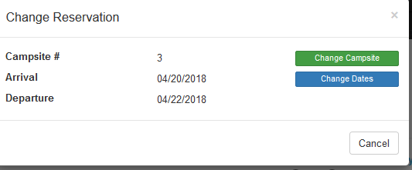
  - If the date needs changed, then switch “Same arrival and departure dates?” from yes to No
    - Select the new dates
  - If the Campsite needs changed, then press “Search Campsite”
  - 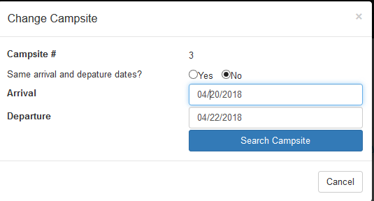
  - Choose the new campsite, notice current one not on menu.
  - 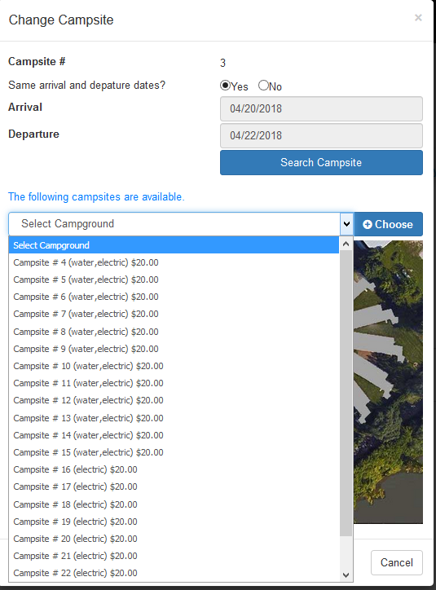
- Edit email Template
  - Go to the Email Templates menu option
  - 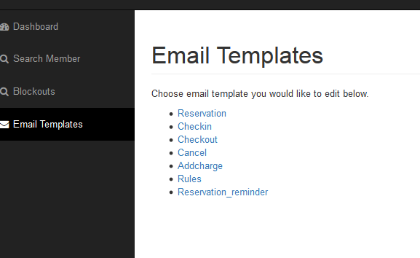
  - Choose one to update
  - The fields with ~ at the beginning and end are special data merge fields.
    - Cancel: has ~member~
    - Checkout: has ~member~ , ~checkin~ , and ~checkout~, and $~charge~
    - Additional charge: ~charge_label~, ~charge_amount~
  - Note: The editor does not handle things well if you copy and paste Microsoft formatting into it, only use plain text when copying, or type the text into the email editor.
- Refunds.
  - First search for the member who needs the refund
  - 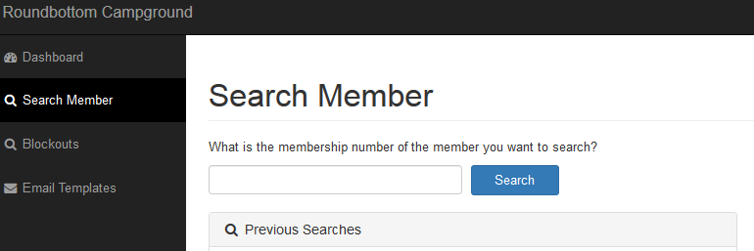
  - After searching for the member, scroll down to the “Additional Charges”
  - 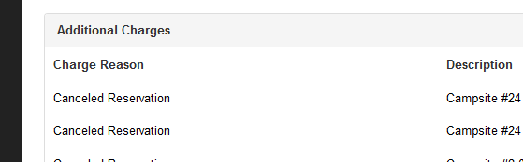
  - Click on View
  - 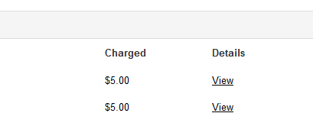
  - Modal with Refund button should be visible. if the charge has not settled yet, it will say ‘Void’ instead of ‘Refund’
  - 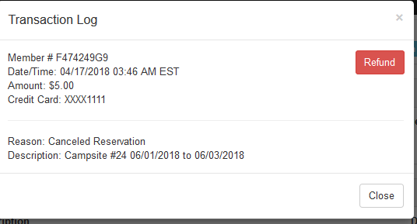
  - Press Refund
  - Asks, “are you sure”, so press “ok” to continue, “cancel” if not.
  - It says “Refund process has begun and the money should be returned to the credit card in 5 to 7 business days. You press ‘ok’.
  - Refund modal goes away automatically.
- Message a member in the system.
  - Search Member
  - 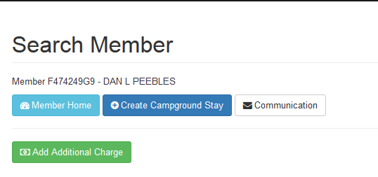
  - Use the Communication button.
  - Shows you 2 things: email logs, and messages
  - 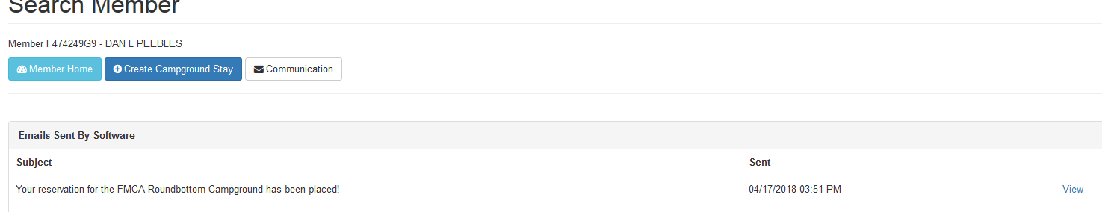
  - To Message Member, press Message Member button.
  - 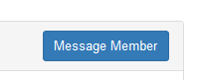
  - 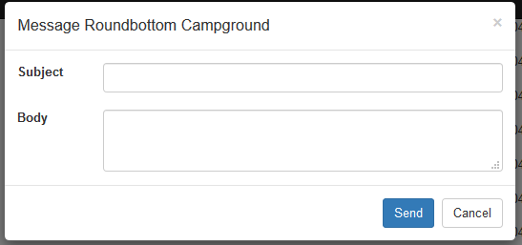
  - Type the subject, body, click send.
  - Member gets a notification:
  - Logged in as member, they see this:
  - 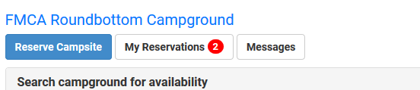
  - 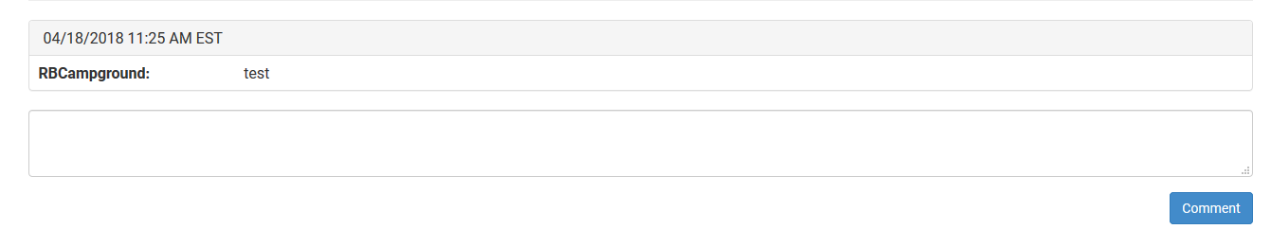
  - Member types, presses Comment, and we see:
  - 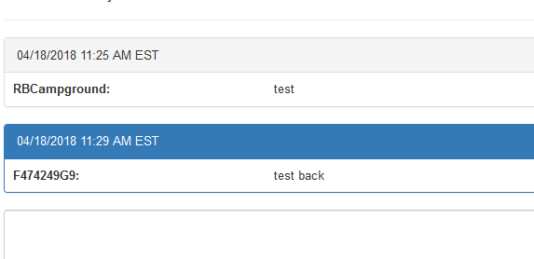
  - Press envelope in corner to see the messages.
  - 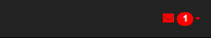
- Someone may book a site while somone else is about to book that same site, so, what will I see if it happens to me?
  - One of the challenges of Reservation software is the race condition. 2 or more people trying to book the same site, at the same time. This is impossible to prevent completely, but programmers can put in checks to make sure this doesn’t happen very often.
  - Say, you are reserving for someone using the back end reservation system:
  - You have site 24 selected, and you’re ready to hit “Book Now”!
  - 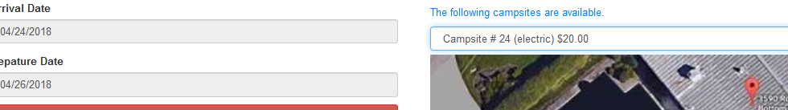
  - However, unknown to you, a customer has also seen that site 24 is available, and he’s beat you to it!
  - If that happens, you will see this message: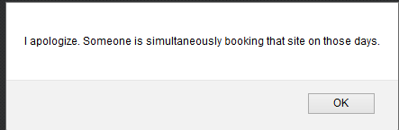
  - When you click ok, you will get an explanation, to move on and try again, you will have to go to the dashboard.
  - 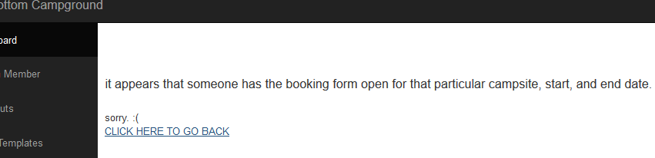
  - Something similar happens for customers who lose the “race condition”, but it redirects them to the search form, since they are already logged in as themselves.
- Reports.
  - The reports section is designed to help you see what’s going on in the campground in any given week. It consists of 2 tables. 1. The camping grid (24 rows for 24 sites) and the summary of arrivals, stays, and departures.’
  - If you click on the drop down to switch from 7-day view to simple search, you will be able to search for folks who are arriving in any given time span. The results will be in a table in your browser, you can also download the results in various formats:
  - 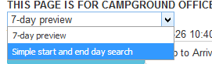
  - 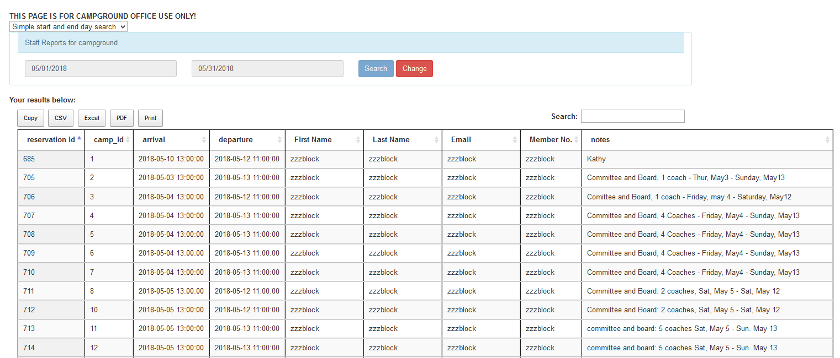
  - The camping grid shows you who is in each site: As you can see, Larry and I booked a stay in site 24 and 23, I arrive to site 24 on 4/24/18 and depart on 4/27/18, the zzzblocks indicate block-outs that I was requested to do.
  - 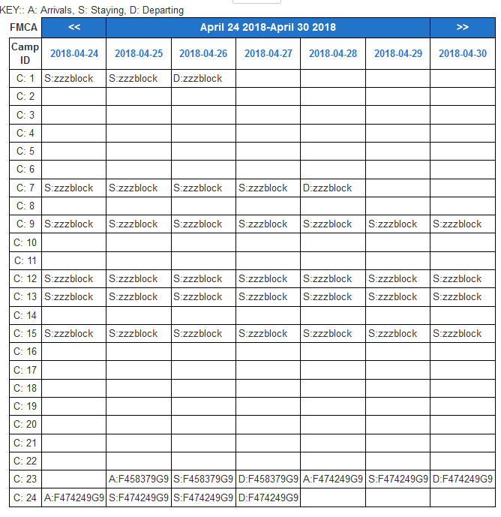
  - You can change the “focus date” to the next day by clicking the >> next to the date in the header.
  - You can change the “focus date” to the previous day by clicking the << next to the date in the header.
  - There is a date entry form above the grid if you want to jump to a desired date. Make sure it’s a valid date, I didn’t add date validation yet.
  - 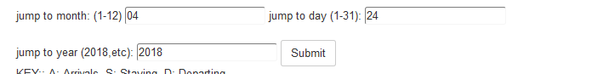
  - All you do is type in the numeric values for month, day, year and click submit.
  - For example, I entered in the date of the Mountaineer chapter rally here 7-12:
  - 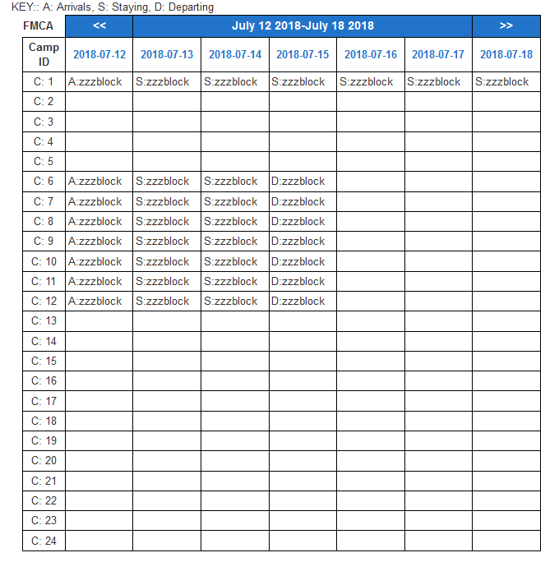
  - Now Let’s look at the arrival, stay, departure summary tables for the week of 7/12:
  - 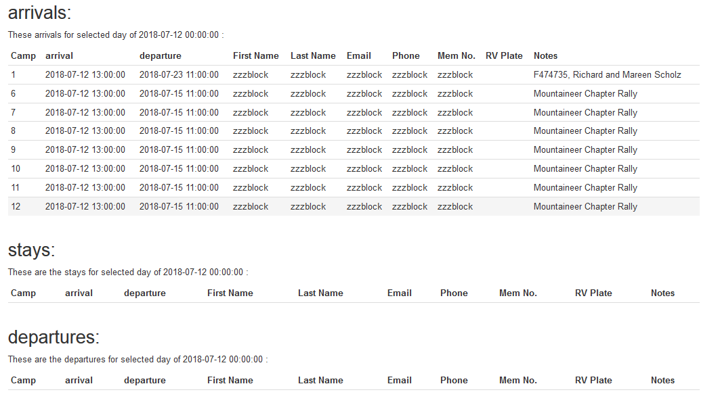
  - If I change the “focus day” to 7/13, then I see that these are staying, but not departing yet.
  - 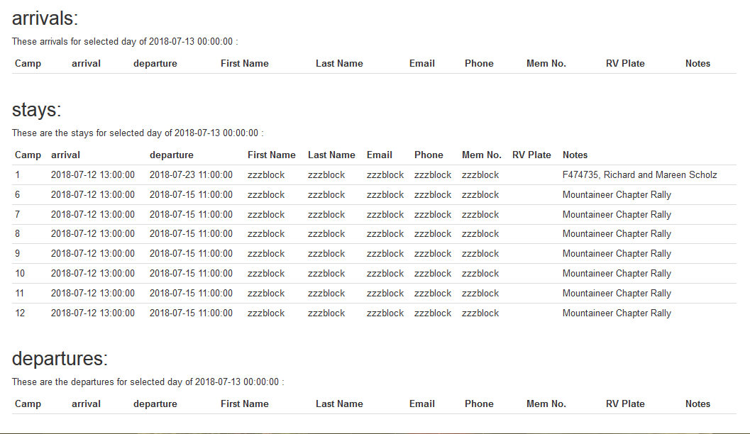
- CHECK – INS
  - 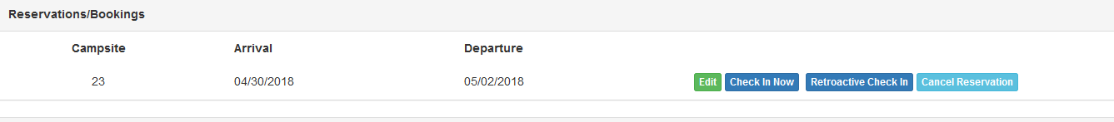
  - When it is appropriate to use the current time to check the member in, Just use the “Check In Now” button
  - When the check in is over a day late, the Retroactive Check In button will appear, if you use this button in the example above, it will retroactively check them in on 4/30
  - If for some reason you need to check them in on a date in between, such as 5/1 in the example above, first use the green edit button to change the arrival to 5/1, then you can perform the check in.
- Cleaning the Browser Cache
  - Sometimes, it is necessary to clear the browser cache if IT updates javascript code. Firefox caches pictures and code to help people load web pages quicker, but sometimes it actually makes the web page you are looking at inaccurate.
  - While focus in in firefox press CTRL+SHIFT+Delte
  - 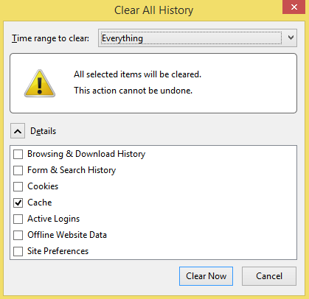
  - In the dialog box that pop ups, select the range you want to delete to. I usually choose “Everything”.
  - Then you can uncheck everything except the “Cache”
  - Then Press the Clear Now Button
  - Go back to the dashboard, and then do your member search again, you should be fine. The Member Search Cache is stored in the campground database, not firefox, so it will still be there.

